Heaven: The Eternal Home of Jesus … and Me!

“Jesus Seeks an Intimate & Eternal Relationship with Me”

Question: What will be the single best thing about Heaven?

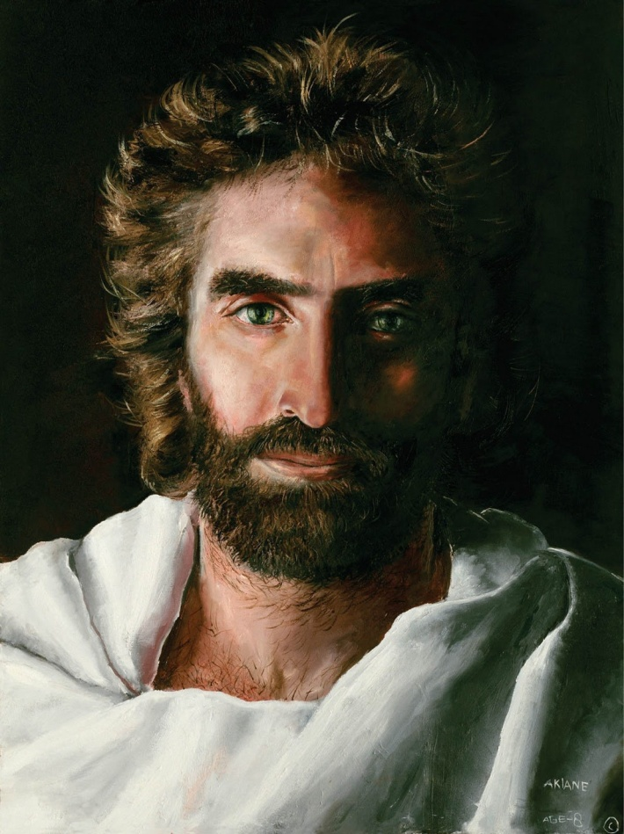

Key Thoughts:

- God loves us with His heart, desires an intimate relationship with us, and hopes we seek Him with our hearts! God chooses to have a personal relationship with us and it brings Him pleasure!
Acts 17:24-27
Eph 1:3-5
Rev 3:20
Psalms 8:4-5

Is 29:13; 62: 4, 12

- God loves us and wants a relationship with us even though we are sinners, ungodly, and fall far short of His glory.
Romans 5:6-8; 3:23

- Jesus loves us and desires a relationship with us so much that He humbled Himself - endured the cross and it’s shame, suffered and died and paid our sin debt to potentially have an eternal, intimate relationship with you and me! (Heb 12:1-3; Phil 2:5-11).

The basic gospel is summarized in I Cor 15:1-8. Some key scriptures include:

- Romans 3:23 “For all have sinned and fall short of the glory of God”

- Romans 6:23 “For the wages (consequences) of sin is death, BUT the gift of God is eternal life through Jesus Christ our Lord”

- I Peter 3:18 “For Christ died for sins once for all, the righteous for the unrighteous, to bring you to God”.

- John 3:16 “For God so loves the world that He gave his one and only Son, that whoever believes in Him shall not perish but have eternal life”.

- II Corinthians 5:21 “God made Him (Jesus) who had no sin to be sin for us, so that in Him we might become the righteousness of God”

- John 1:12 “… to all who received Him (Jesus), to those that believe in His name, He gave the right to become children of God”

- Romans 10:9, 13 “… if you confess with your mouth ‘Jesus is Lord’ and believe in your heart that God raised Him from the dead, you will be saved … Everyone who calls on the name of the Lord will be saved”

- If we have a personal relationship with Jesus, He lives in us, and so does God the Father and the Holy Spirit (John14:16-17, 20-23; Romans 8:9-11; 2 Corinthians 13:5). Someday we will see Jesus face-to-face and spend eternity with Him! (John 14:1-3; Revelation chapters 21 & 22).

- Having a personal relationship with Jesus has its benefits now too. Here are some key thoughts from John chapter 10, verses 3 - 30:

Verse 3: Jesus knows us by name (individually)
Verses 4-5: Jesus leads us
Verses 7-9: Jesus is “the Gate” – the only way of salvation. Jesus takes care of us.
Verse 10: Jesus wants to give us a full life (spiritually meaningful and relationally rich)
Verses 11-15: Jesus is the “Good Shepherd”; He knows and cares for us and willingly gave His life for us.
Verses 24-25: Jesus is the Messiah/Christ/Savior. His miracles alone prove this fact.
Verses 28-30: Jesus gives us eternal life; we shall never perish and no one can snatch us out of the hands of Him or His Father

- God knows us individually; He wants a “sacred romance”, a “marriage” type relationship with us!

• God knows us individually (Psalm 139; John 10:3, 14; 2 Tim 2:19; Is 43:1, 45:3, 49:1)

The Bible speaks of a “marriage” type relationship between God/Jesus and the Church/Christians

Is 54:5-7; Jer 2:2, 3:14, 20, 31:32; Hosea 2:2-5, 3:1, 9:1
Song of Solomon?
Matthew 9:14-15
Eph 5:31-32
Rev 19:6-9 (Is 25:6; Mat 22:2-12)

- Jesus “courts” us (seeks an intimate relationship with us) in a variety of ways:

• By His creation (Rom 1:18-20; Ps 19:1-6)
• By His word (Jn 14:21, 23)
• By the Holy Spirit (Jn 14:15-18)
• By the “good gifts” He gives us (Mt 7:11; Jm 1:17)
• By the church and other Christians (Acts 2:42-47)
• By past demonstrations of His love (e.g. the Cross) (Rom 5:8)
• By worship/praise/thanksgiving (Jn 14:23-24; Eph 5:19-20; Col 3:16-17)
• By speaking to our hearts (I Ki 19:10-13; Rev 3:20)
• By telling us of His future plans for us (Jn 14:1-3)

- Jesus is excitedly looking forward to us being in Heaven with Him!

• He wants to show us His glory! (John 17:24; Ex 33:11,18-20)

• He wants us to reveal our glory (which comes through Him) (Rom 8:14-25)

There are “new” things He wants to give us for our enjoyment with Him!!

• New name (a private name known only by us and Him) Rev 2:17; Is 62:2, 65:15

• New home (special dwelling place just for us) John 14:1-3

• New body (similar to His) I Cor 15:35-58

• New clothes (white robes) Rev 3:4-5

• A new life (eternal life full of incomprehensible joys, adventures and relationships) I Cor 2:9; Rev 21 & 22, etc

