Wesfriesen.com
Jephthah: From Outcast to National Hero and Leader
The story of Jephthah shows us that we can be successful no matter what our background – even having a prostitute for a mother and being ostracized by your siblings. When God is with us, nothing can stop us from accomplishing what He wants us to do.
Background: Judges 10:6 – 18
Jephthah to the rescue: Judges 11:1 – 40
Epilogue: Judges 12:1-7
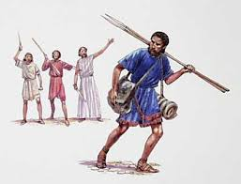
Key Lessons Learned:
- Sin, including idolatry, has its consequences

- God honors our repentance from sin

- People can be cruel and judgmental

- God can use us, regardless of our backgrounds

- With the Spirit of the Lord we will be successful

- God gives us the victory

- Don’t make foolish vows!

- Other?

