“JESUS LOVES ME THIS I KNOW, FOR THE BIBLE TELLS ME SO!”

Elder Wes Friesen

Six Life-Changing Biblical Principles:

- Every good __________ we have received comes from God!
(James 1:17 “Every good and perfect gift is from above, coming down from the Father…”)

- We should be ____________ for all the gifts God has given us! We should be overflowing with thankfulness and regularly praising God privately and publicly!

Colossians 2:6-7 ”So then, just as you received Christ Jesus as Lord, continue to live in him, rooted and built up in him, strengthened in the faith as you were taught, and overflowing with thankfulness”.

Colossians 3:17 “And whatever you do, whether in word or deed, do it all in the name of the Lord Jesus giving thanks to God the Father through Him”.

Ephesians 5:19- 20 “… sing and make music in your heart to the Lord, always giving thanks to God the Father for everything, in the name of the Lord Jesus Christ”.

Hebrews 13:15-16 “Through Jesus, therefore, let us continually offer to God a sacrifice of praise – the fruit of lips that confesses His name”.

I Thessalonians 5:16-18 ”Be joyful always; pray continually; give thanks in all circumstances, for this is God’s will for you in Christ Jesus”.

Psalms 100:4-5 “Enter His gates with thanksgiving, and his courts with praise; give thanks to Him and praise His name. For the Lord is good and His love endures forever; His faithfulness continues through all generations”.

What are you thankful for?

Provisions Possessions Pets Privileges Positions Pastors People

- The greatest gift we can receive from God the Father is a _____________________ with Him and His Son, Jesus Christ.

- Jesus the man understands us and is caring and compassionate. He humbled Himself, “walked in our skin” and knows what being human is all about. His favorite title for Himself was the “Son of Man”.

- Jesus the God has supernatural power to help us in our time of need. Others frequently used the title for Jesus of “Son of God”.

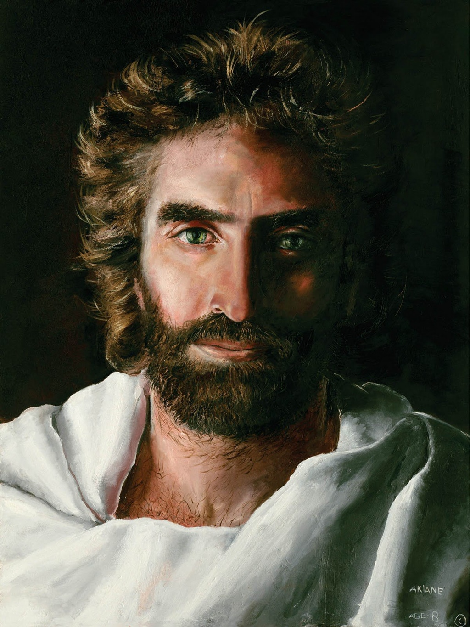

CASE STUDY: Story of Jesus and Lazarus in John chapter 11.
In this story we clearly see the humanity and also the divinity of Jesus in action.



- Jesus ________ us greatly – and wants a personal relationship with us and it brings Him pleasure! (Ephesians 1:3-5, 2:4) And Jesus loves us and desires a relationship with us so much that He humbled Himself and came to earth to pay our sin debt (Philippians 2:5-11) - and offers us the FREE gift of salvation!

- Romans 3:23 “For all have sinned and fall short of the glory of God”

- Romans 6:23 “For the wages (consequences) of sin is death, BUT the gift of God is eternal life through Jesus Christ our Lord”

- II Corinthians 5:21 “God made Him (Jesus) who had no sin to be sin for us, so that in Him we might become the righteousness of God”

- John 1:12 “… to all who received Him (Jesus), to those that believe in His name, He gave the right to become children of God”

- Romans 10:9, 13 “… if you confess with your mouth ‘Jesus is Lord’ and believe in your heart that God raised Him from the dead, you will be saved … Everyone who calls on the name of the Lord will be saved”

- If we have a personal relationship with Jesus, He ________ in us, and so does God the Father and the Holy Spirit (John14:16-17, 20-23; Romans 8:9-11; 2 Corinthians 13:5). Someday we will see Jesus face-to-face and spend eternity with Him! (John 14:1-3; Revelation chapters 21 & 22).

- Having a personal relationship with Jesus has its ___________. Here are some key thoughts from John chapter 10, verses 3 - 30:

Verse 3: Jesus knows us by name (individually)
Verses 4-5: Jesus leads us
Verses 7-9: Jesus is “the Gate” – the only way of salvation. Jesus takes care of us.
Verse 10: Jesus wants to give us a full life (spiritually meaningful and relationally rich)
Verses 11-15: Jesus is the “Good Shepherd”; He knows and cares for us and willingly gave His life for us.
Verses 24-25: Jesus is the Messiah/Christ/Savior. His miracles alone prove this fact.
Verses 28-30: Jesus gives us eternal life; we shall never perish and no one can snatch us out of the hands of Him or His Father

Closing Thought: Jesus is with is 24/7. We can choose to consistently practice His presence, and claim as our own Philippians 4:13 “I can do all things through Christ who strengthens me”.

Key Takeaway: “Jesus loves me this I know, for the Bible tells me so”. The greatest gift we can ever receive is a personal relationship with God the Father and His Son Jesus Christ. God loves me and wants to give us this gift – it’s up to us to receive it. This gift truly never stops giving – starting now in this life and then continuing for eternity!

Keep Reading

Monday: John 3:1-21
Tuesday: John 1:1-8; Philippians 2:5-11
Wednesday: Ephesians 1:3-14
Thursday: I John 4:7-21
Friday: Hebrews 4:14-16; Colossians 1:15-20

Digging Deeper and Getting Personal

Follow-up questions for GROUP discussion and PERSONAL study

What are some things that you are thankful for?

Where are you in your journey with Jesus and what does He mean to you right now?

Think about a personal challenging experience. What helped you through this? What role did Jesus play?

Read John Chapter 11

What are some ways that Jesus demonstrated His humanity? Why is it important to us that Jesus was human (refer to Hebrews 4:14-16)?

What are some ways that Jesus demonstrated His divinity (that He was God)? Why is it important to us that Jesus is God?

In verses 45-57 we see that some people believed and followed Jesus after the resurrection of Lazarus – but others did not follow Jesus and wanted Him dead. When confronted with Jesus, why do some people believe and follow while others don’t believe? What should be our response to those that have not yet believed?

Read John Chapter 10, verses 1-30

What are some of the key privileges we have by having a personal relationship with Jesus? Why are they important?

Final thoughts

What is one or two key take-ways for you from this week’s bible lesson?

SERMON AND PERSONAL STUDY NOTES

John Chapter 11 – Story of Jesus and Lazarus

