Mary and Martha
“Sisters with Different Personalities But Similar Faith in Jesus”
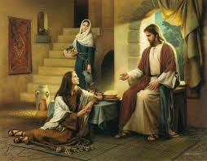
Cast of Characters:

Mary and Martha – Mary and Martha were unmarried sisters who lived with their brother Lazarus in Bethany, a small town just two miles east of Jerusalem. Jesus and His disciples often stayed with them, and Jesus had a special friendship with the three of them.

Jesus Christ – Son of Man and Son of God. Jesus loved Mary, Martha and their brother Lazarus and liked to hang out with them.

THE STORY: Three passages speak of Mary and Martha and have valuable lessons for us:

1) Luke 10:38-42

2) John 11:1-44

3) John 12: 1-8

SOME LESSONS FROM MARY and MARTHA’s LIFE:
- Duty is important, but devotion is even more important.

- We should focus on the most important things – which includes relationships with God and people.

- There is room for different personality types in Christ’s kingdom.

- Jesus cares about us and what happens in our lives.

- Nothing is impossible for Jesus.

- Mary modeled extreme devotion to Jesus with all her resources (time and possessions).

- Both women modeled great faith in Jesus.

- Other?

